**Q1:**

**Part 1:**

**Solution:** org 100h mov ah, 10100011b ror ah,1 ret

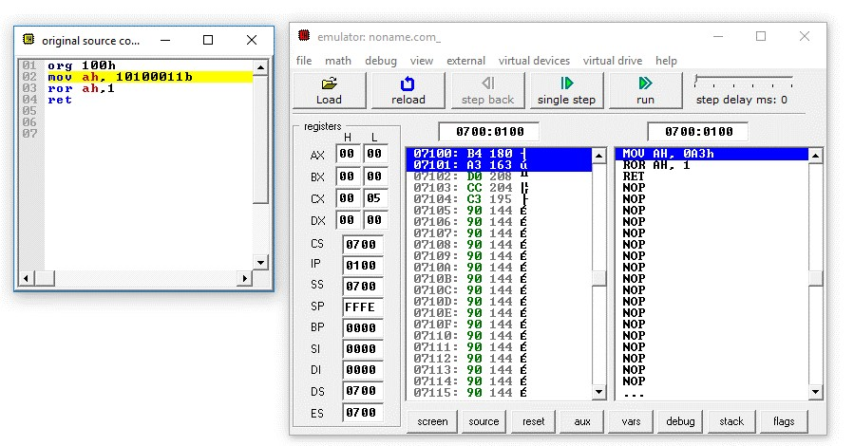

org 100h mov ah, 10100011b

sal ah,1 ret

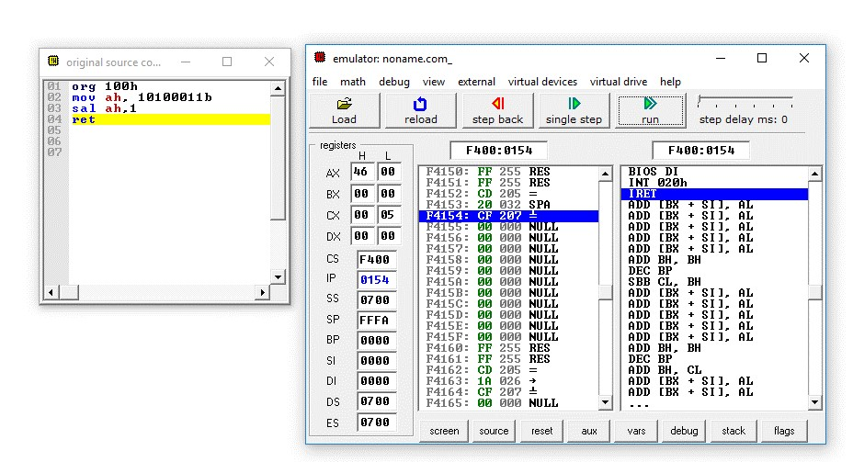

**Part b)**

**Solution:**

Org 100H says that the machine code starts from address 100h in this segment, effective address is CS: 100H.

Whereas A stack is an array-like data structure in the memory in which data can be stored and removed from a location called the 'top' of the stack.

**Q2:**

**Part 1**

**solution:** org 100h

mov al,5 mov bl,1

label:

sub al,bl

jmp label

ret

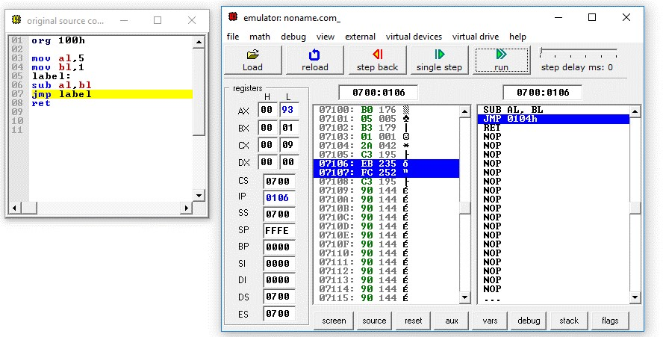

**part 2)**

**solution:**

org 100h

.MODEL SMALL

.STACK 100H

.DATA

; The string to be printed

STRING DB 'PAKISTAN ', '$ '

.CODE

MAIN PROC FAR

MOV AX,@DATA

MOV DS,AX

CALL REVERSE

LEA DX,STRING

MOV AH, 09H

INT 21H

MOV AH, 4CH

INT 21H

MAIN ENDP

REVERSE PROC

MOV SI, OFFSET STRING

MOV CX, 0H

LOOP1:

; compare

MOV AX, [SI]

CMP AL, '$'

JE LABEL1

PUSH [SI]

INC SI

INC CX

JMP LOOP1

LABEL1:

MOV SI, OFFSET STRING

LOOP2:

CMP CX,0

JE EXIT

POP DX

XOR DH, DH

MOV [SI], DX

INC SI

DEC CX

JMP LOOP2

EXIT:

MOV [SI],'$ '

RET

ret

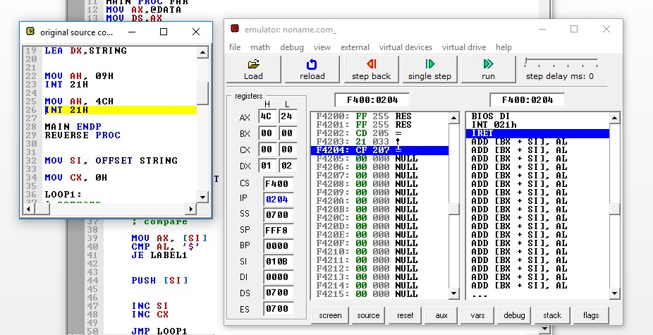

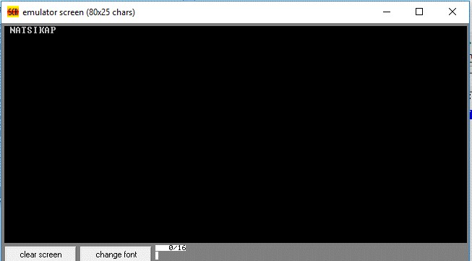

**solution:**

# part 3)

org 100h

mov ax, 0100100100100100b and bx, 1001001001001001b

xor ax, bx;1101101101101101

02-134202-092

